SkillSwap – Project Documentation
Oct 13, 2026 · @Vrun

1. Introduction
SkillSwap is a web application where college students teach a skill they already know in exchange for learning a skill they want, so every connection is a two-way swap rather than a one-way favour.
Most student platforms only match people with similar interests. SkillSwap matches reciprocal needs: if Student A knows Java and wants to learn Photoshop, and Student B knows Photoshop and wants to learn Java, A can find B, view the profile and send an exchange request that B accepts or rejects.
Objectives
- Let students list the skills they can teach and the skills they want to learn.
- Help students discover suitable partners through skill search and match highlighting.
- Manage the full request cycle: send, receive, accept, reject and track status.
- Give an administrator control over users, skills and exchange requests.
- Keep the code simple enough to explain line by line in a practical exam.
Technology stack
Layer | Technology
Frontend | HTML, CSS, a little inline JavaScript for delete confirmations
Backend | Core PHP 8 with MySQLi prepared statements
Database | MySQL (InnoDB, foreign keys)
Authentication | PHP sessions, password_hash / password_verify
Development setup | PHP built-in server (php -S) with a local MySQL; Docker as backup

2. Users and roles
SkillSwap has two roles, stored in the role column of the users table: students do the swapping, and an administrator keeps the platform clean.
Role | How the account is created | Can do | Cannot do
Student | Self-registration on register.php | Edit own profile and skills, search students, view profiles, send requests, accept or reject requests received, track sent requests | Open admin pages, change another student's profile or skills, send a request to themselves, answer a request addressed to someone else
Administrator | Inserted by database.sql (admin@skillswap.com) | View platform statistics, list users and delete students, add and delete skills, view every exchange request with its status | Delete their own account, use the student pages (they are redirected to the admin panel)
The administrator's role is read from the database again on every admin page and action, so changing a URL or editing the session cannot grant admin access.

3. Functionality
The student side covers nine features, from registration to accepting a swap, and the admin side is a four-tab panel. A perfect match is a student who teaches something you want to learn and wants something you can teach.
Student features
Feature | Page | What it does
Register | register.php | Validates input, rejects a duplicate email, stores a hashed password, then redirects to login
Login and logout | login.php, logout.php | Starts or destroys the session; one generic error message for wrong credentials
Dashboard | dashboard.php | Live counts of skills offered, skills wanted, pending requests received and accepted exchanges, plus up to three perfect matches
Profile | profile.php | Edit name, course, year and bio
My skills | skills.php | Add or remove skills the student can teach (OFFER) or wants to learn (WANT), chosen from the skills table
Find students | students.php | Search by skill name; cards show offered and wanted skills and a match badge; the logged-in student never appears
Student profile | student.php | Public profile with skills that match the viewer highlighted, and the swap request form
Send request | request.php | Checks both skills, blocks requests to self and duplicate pending requests, saves the request as PENDING
My requests | requests.php | Received and sent requests as cards; the receiver can accept or reject a pending request
Administrator features (all on admin.php)
Tab | What it does
Overview | Real counts of students, skills, exchange requests and pending requests
Users | List all users; delete a student (their skills and requests are removed with them)
Skills | Add a new skill with a category; delete a skill
Requests | View every exchange request with sender, receiver, skills, date and status

4. Application workflow
A swap runs from registration to a decision in seven steps, and only the receiver can decide.
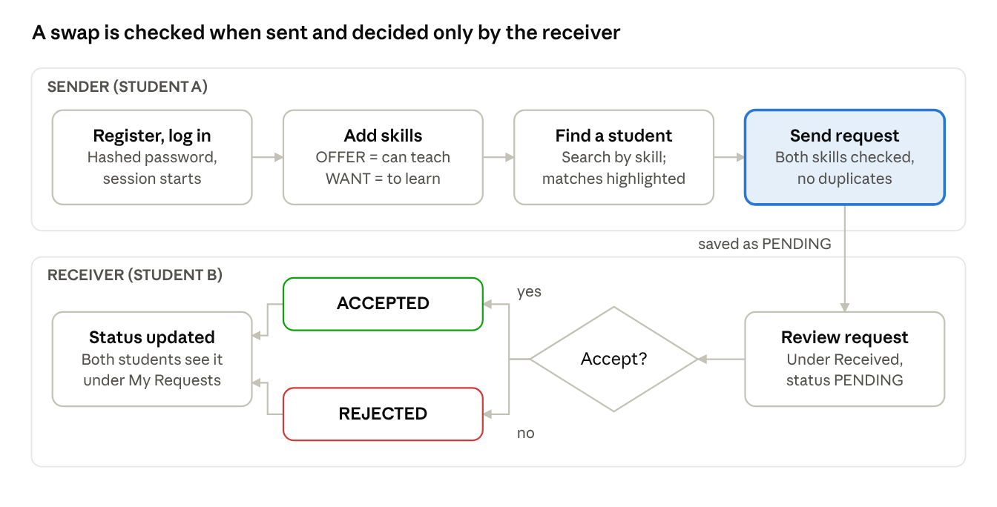
swap workflow · two lanes, one decision
The sender's request is saved as PENDING; the receiver's accept or reject then updates the status that both students see.
- Register and log in. The student creates an account and logs in; the session stores their user ID and role.
- Add skills. In My Skills the student lists what they can teach (OFFER) and what they want to learn (WANT).
- Find a student. Search by skill name; a card marked perfect match teaches what you want and wants what you teach.
- Open the profile. Matching skills are highlighted, and the swap form lists your OFFER skills and the student's OFFER skills.
- Send the request. request.php validates both skills and saves the request as PENDING.
- Receiver decides. Under My Requests the receiver accepts or rejects; only the receiver of a pending request can do this.
- Both see the result. The Sent and Received lists show ACCEPTED or REJECTED.

5. Database design
The skillswap database has four InnoDB tables: users and skills hold the entities, user_skills links a student to a skill as OFFER or WANT, and exchange_requests records each swap proposal.
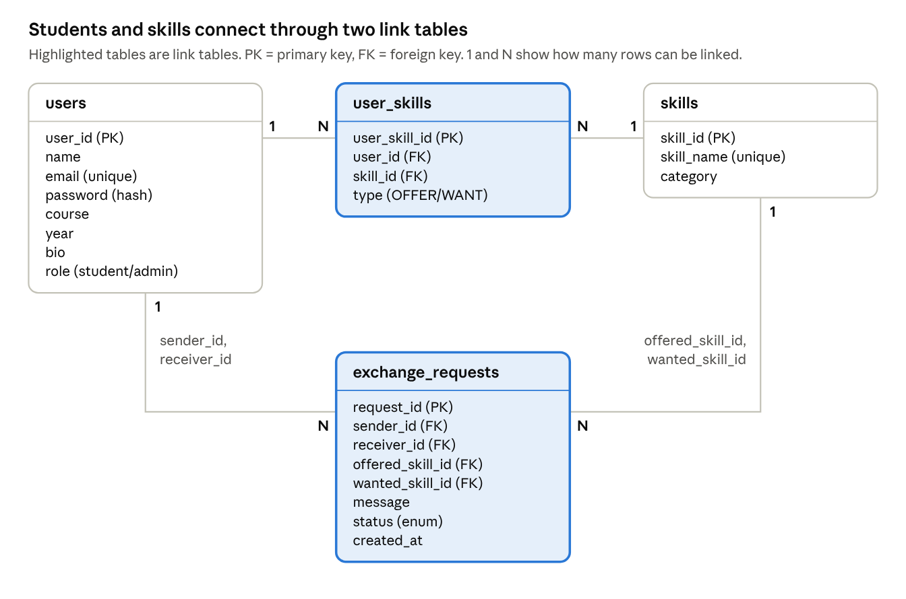
ER diagram · 4 tables, 4 relationships
A student has many user_skills rows and a skill appears in many of them; every exchange request points to two students and two skills.
users
Column | Type | Key or rule
user_id | INT, auto-increment | Primary key
name | VARCHAR(100) | Required
email | VARCHAR(150) | Required, unique
password | VARCHAR(255) | Required, bcrypt hash
course | VARCHAR(100) | Optional
year | VARCHAR(30) | Optional
bio | TEXT | Optional
role | ENUM('student','admin') | Default student
skills
Column | Type | Key or rule
skill_id | INT, auto-increment | Primary key
skill_name | VARCHAR(100) | Required, unique
category | VARCHAR(50) | Required (Technology, Creative, Academic, Lifestyle)
user_skills
Column | Type | Key or rule
user_skill_id | INT, auto-increment | Primary key
user_id | INT | Foreign key to users, ON DELETE CASCADE
skill_id | INT | Foreign key to skills, ON DELETE CASCADE
type | ENUM('OFFER','WANT') | Required; (user_id, skill_id, type) is unique
exchange_requests
Column | Type | Key or rule
request_id | INT, auto-increment | Primary key
sender_id | INT | Foreign key to users, ON DELETE CASCADE
receiver_id | INT | Foreign key to users, ON DELETE CASCADE
offered_skill_id | INT | Foreign key to skills, ON DELETE CASCADE
wanted_skill_id | INT | Foreign key to skills, ON DELETE CASCADE
message | TEXT | Optional
status | ENUM('PENDING','ACCEPTED','REJECTED','COMPLETED') | Default PENDING
created_at | TIMESTAMP | Default current time

6. Project structure
The project is a flat set of core PHP pages plus an includes/ folder for code every page shares.
File | Purpose
index.php | Public landing page with a live student count
register.php, login.php, logout.php | Account creation, authentication, session end
dashboard.php | Student home with live statistics and best matches
profile.php | View and edit the student's own profile
skills.php | Manage OFFER and WANT skills
students.php, student.php | Student search and a single public profile
request.php | Processes the swap request form
requests.php | Sent and received requests, accept and reject
admin.php | Administrator panel (overview, users, skills, requests)
db.php | MySQL connection settings
database.sql | Creates the database, four tables and sample data
includes/helpers.php | Session start, e() escaping, flash messages, CSRF, login and admin checks
includes/header.php, footer.php | Shared navbar and footer for every page
includes/cards.php | Student cards, skill chips, match query, SVG icons
styles.css | Single stylesheet for all pages

7. Security and validation
Every check runs on the server, so it still applies if someone edits the page in the browser.
- SQL injection: every query that uses user input is a prepared statement.
- Passwords: stored with password_hash, checked with password_verify; the session ID is regenerated at login, and a wrong email or password gives the same message.
- CSRF: each form carries a session token that csrf_check() verifies before any change.
- XSS: all user text is escaped with htmlspecialchars through the e() helper.
- Safe methods: every change uses POST and ends with a redirect and a flash message.
- Ownership: a skill is removed only with AND user_id = <session user>; a request is accepted or rejected only with receiver_id = <session user> and status PENDING; the sender of a request always comes from the session, never the form.
- Roles: require_admin() re-reads the role from the database; students cannot reach admin pages and admins are redirected away from student pages.
- Data integrity: unique keys on email, skill name and (user, skill, type); foreign keys with ON DELETE CASCADE so deleting a user or skill leaves no orphan rows.
Form validation
Form | Checks
Register | Name and course required, valid email, password of 6 or more characters that matches the confirmation, year from a fixed list, email not already registered
Profile | Same field rules, bio limited to 500 characters
Add skill | Type is OFFER or WANT, the skill exists, not already added
Swap request | Not to self; receiver exists; offered skill is in the sender's OFFER list; wanted skill is in the receiver's OFFER list; no identical pending request; message at most 300 characters

8. Screenshots
Paste one screenshot under each caption below, logged in as the role shown.
Figure 1 – Home page (logged out)
Paste screenshot here
Figure 2 – Registration form (with a validation error shown)
Paste screenshot here
Figure 3 – Login page
Paste screenshot here
Figure 4 – Student dashboard (statistics and best matches)
Paste screenshot here
Figure 5 – My Skills (teach and learn columns)
Paste screenshot here
Figure 6 – Find students (search results with a perfect-match badge)
Paste screenshot here
Figure 7 – Student profile and swap request form (matching skills highlighted)
Paste screenshot here
Figure 8 – My Requests (received with Accept and Reject, and sent)
Paste screenshot here
Figure 9 – Admin overview and users tab
Paste screenshot here
Figure 10 – Admin skills and requests tabs
Paste screenshot here

9. Setup, test accounts and future scope
The project needs PHP 7.4 or newer with the mysqli and mbstring extensions, and a running MySQL or MariaDB server.
- Put all project files in one folder.
- Open db.php and set the MySQL user, password and port.
- Run database.sql once (mysql -u root -p < database.sql). It creates the skillswap database, four tables, 16 skills and the test accounts. Running it again deletes all data.
- In the project folder run php -S localhost:8080.
- Open http://localhost:8080 in a browser.
Test accounts
Role | Email | Password
Administrator | admin@skillswap.com | admin123
Student | ruchit@test.com, rahul@test.com, meera@test.com, diya@test.com | student123
Limitations and future scope
- The COMPLETED status exists in the database but has no button yet.
- No ratings or reviews, chat, email notifications or password reset.
- Search results are not paginated and form errors appear only after submitting.
- Possible next steps: mark an accepted swap as completed, rate a partner, and notify students by email.

